Lesson 1: Characteristics of Living Organisms

What makes something alive? State what is meant by the acronym MRS C GREN.
M …………………………………………………………………………………………………………………………………………………….
R ………………………………………………………………………………………………………………………………………………………
S ………………………………………………………………………………………………………………………………………………………
C ………………………………………………………………………………………………………………………………………………………
G ……………………………………………………………………………………………………………………………………………………..
R ………………………………………………………………………………………………………………………………………………………
E ………………………………………………………………………………………………………………………………………………………
N ………………………………………………………………………………………………………………………………………………………

True or False?
- All living organisms have eyes.
- All living organisms breathe.
- All living organisms need nutrition.
- All living organisms can reproduce.
- All living organisms do digestion.

Exam Practice
Q1. All living organisms have certain characteristics.
(a) Describe what is meant by the following characteristics:
(i) respiration
(2)
.............................................................................................................................................
.............................................................................................................................................
.............................................................................................................................................
.............................................................................................................................................
(ii) control of their internal conditions
(2)
.............................................................................................................................................
.............................................................................................................................................
.............................................................................................................................................
.............................................................................................................................................

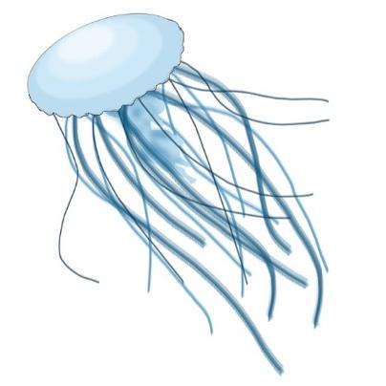
There are over 2000 types of jellyfish around the world. Jellyfish swim by rhythmic pulsations of the umbrella. The tentacles on a jellyfish are covered with millions of stinging cells. Jellyfish usually feed on small fish that get caught in their tentacles or sometimes even other jellyfish.
Jellyfish take oxygen into their cells directly from the water around them. Jellyfish don’t actually have brains but they do have something called a nerve net which can coordinate responses. Most Jellyfish release sperm or eggs directly into the water around them. Jellyfish have no blood, bones or hearts. But come of them can do incredible things like glow in the dark.
Jellyfish are some of the oldest living creatures on Earth and have probably been around on the planet for over 600 million years. Jellyfish numbers are increasing as they are one of the few living organisms that are thriving with warmer more acidic oceans.
Q2. Suggest and explain 3 pieces of evidence from the passage that show that jellyfish are a type of living organism.
(3)
.............................................................................................................................................
.............................................................................................................................................
.............................................................................................................................................
.............................................................................................................................................
Q3. Suggest how jellyfish carry out excretion.
(1)
.............................................................................................................................................
.............................................................................................................................................

Q4: Some jellyfish can clone themselves to make identical copies. Suggest how this also shows they are living organisms.
(1)
.............................................................................................................................................
.............................................................................................................................................

Cell Diagram
Examples
Characteristics
Kingdom | Animal | Plant | Fungi | Bacteria | Protoctist

Exam Practice Questions
Q1.
The diagram shows Chlamydomonas, a single-celled protoctist that is found in water.
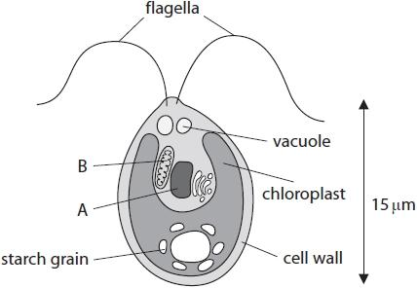
(a) Name the structures labelled A and B.
(2)
A ..........................................................................................................................................
B ..........................................................................................................................................
(b) (i) Chlamydomonas has some structures that are normally found in plant cells, but not found in animal cells.
Name two of these structures.
(2)
1 ..........................................................................................................................................
2 ..........................................................................................................................................
(ii) State why Chlamydomonas is not classified as a plant.
(1)
.............................................................................................................................................
.............................................................................................................................................
(c) Explain how Chlamydomonas obtains energy.
(2)
.............................................................................................................................................
.............................................................................................................................................
.............................................................................................................................................
.............................................................................................................................................
(d) Chlamydomonas has flagella.
Suggest a function of these flagella.
(1)
.............................................................................................................................................
.............................................................................................................................................

